MINI PROJECT

NAME : MADAN PRASAD S

REG N0: RA2111003011006

UNIT CONVERTER

CODE:

#include <stdio.h>

int main(){

int section;

float temp_input,far_input,far_to_cel,cel_input,cel_to_far,dis_input,km_input,km_to_miles,miles_input,miles_to_km,weight_input,kg_input, kg_to_pound,pound_input,pound_to_kg;

printf("Unit Converter\n");

printf("Choose the type of conversion\n");

printf("Press 1 for Temprature conversion\n");

printf("Press 2 for Distance conversion\n");

printf("Press 3 for Weight conversion\n");

scanf("%d",&section);

if(section == 1)

{

printf("Choose the type of conversion you want to make\n");

printf("Press 1 for Fahrenheit to Celsius\n");

printf("Press 2 for Celsius to Fahrenheit\n");

scanf("%f",&temp_input);

if(temp_input == 1){

printf("Enter the Fahrenheit degree: \n");

scanf("%f",&far_input);

far_to_cel = ((far_input-32) * (5.0/9.0));

printf("Temprature in Celsius: %.2f \n",far_to_cel);

}

else{

printf("Enter the Celsius degree: \n");

scanf("%f",&cel_input);

cel_to_far = ((9.0/5.0)*cel_input + 32);

printf("Temprature in Fahrenheit: %.2f \n",cel_to_far);

}

}

else if(section == 2){

printf("Choose the type of conversion you want to make\n");

printf("Press 1 for Kilometers to Miles\n");

printf("Press 2 for Miles to Kilometers\n");

scanf("%f",&dis_input);

if(dis_input == 1){

printf("Enter the distance in Kilometers: \n");

scanf("%f",&km_input);

km_to_miles = km_input*0.62137;

printf("Distance in Miles: %.2f \n",km_to_miles);

}

else{

printf("Enter the distance in Miles: \n");

scanf("%f",&miles_input);

miles_to_km = miles_input * 1.60934;

printf("Distance in Kilometer: %.2f \n",miles_to_km);

}

}

else{

printf("Choose the type of conversion you want to make\n");

printf("Press 1 for Kilogram to Pounds\n");

printf("Press 2 for Pounds to Kilogram\n");

scanf("%f",&weight_input);

if(weight_input == 1){

printf("Enter the weight in Kilogram: \n");

scanf("%f",&kg_input);

kg_to_pound = kg_input * 2.20462;

printf("Weight in Pounds is: %.2f \n",kg_to_pound);

}

else{

printf("Enter the weight in Pounds: \n");

scanf("%f",&pound_input);

pound_to_kg = pound_input * 0.453592;

}

}

}

OUTPUTS

CASE 1 :

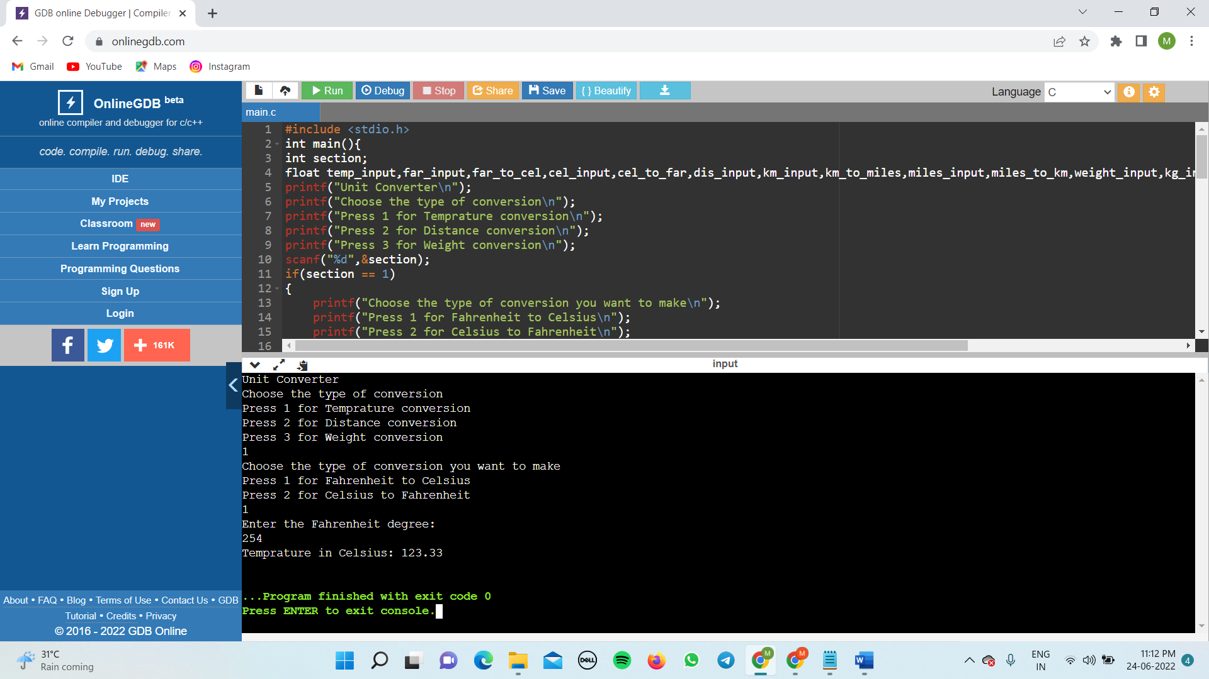

CASE 2 :

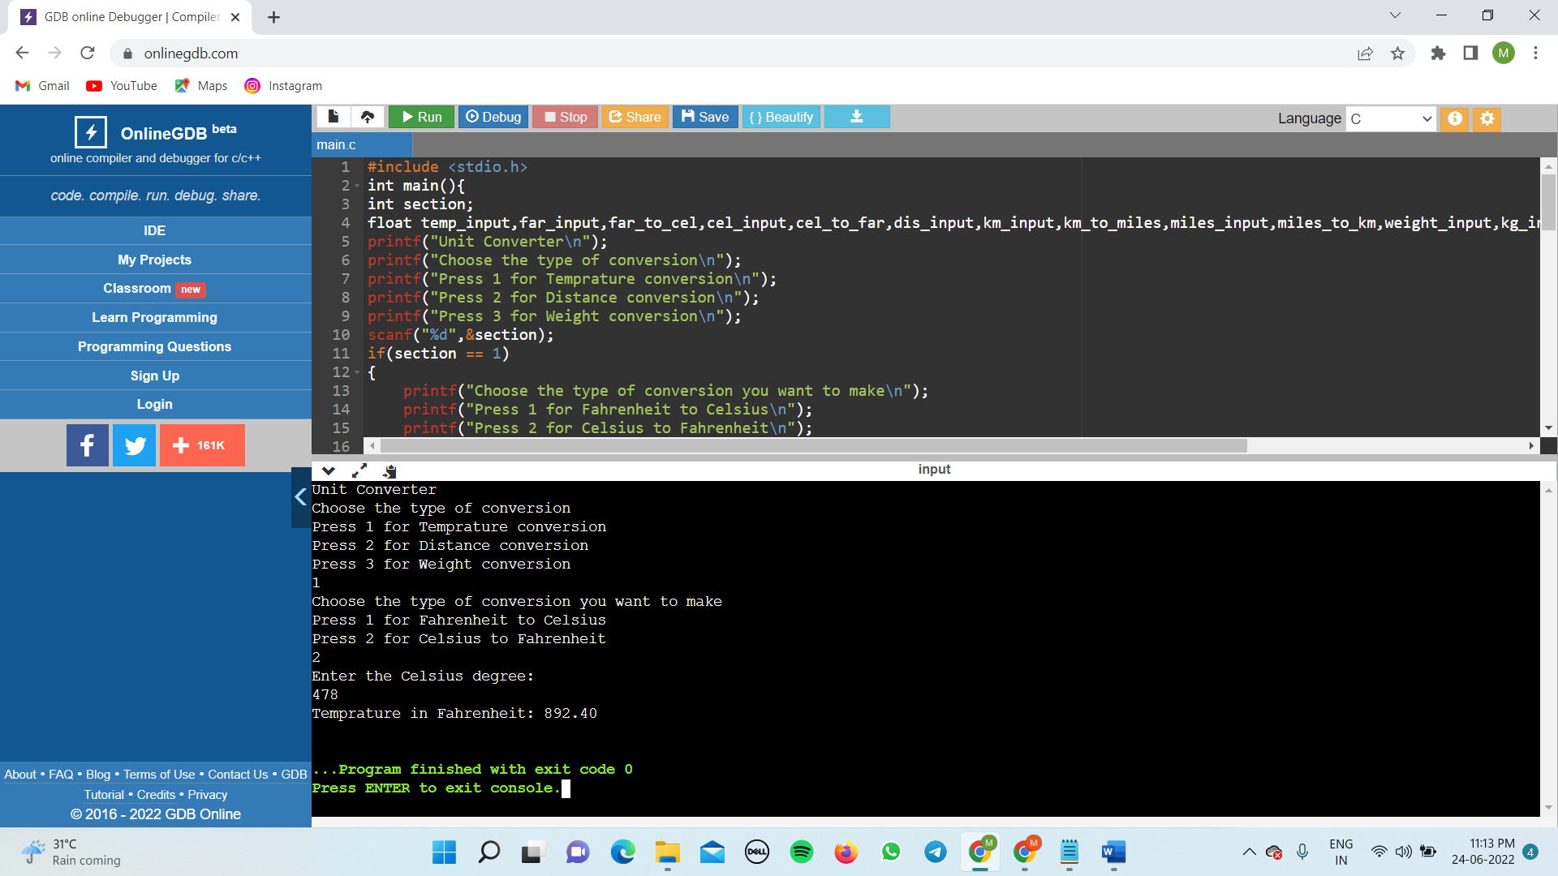

CASE 3 :

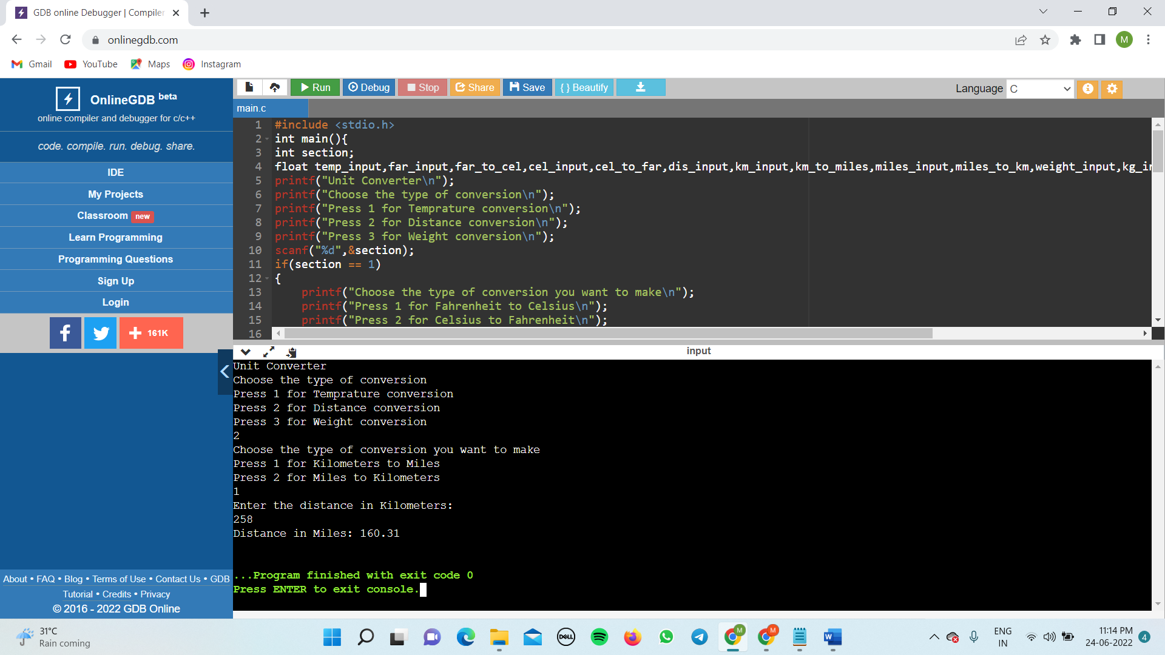

CASE 4 :

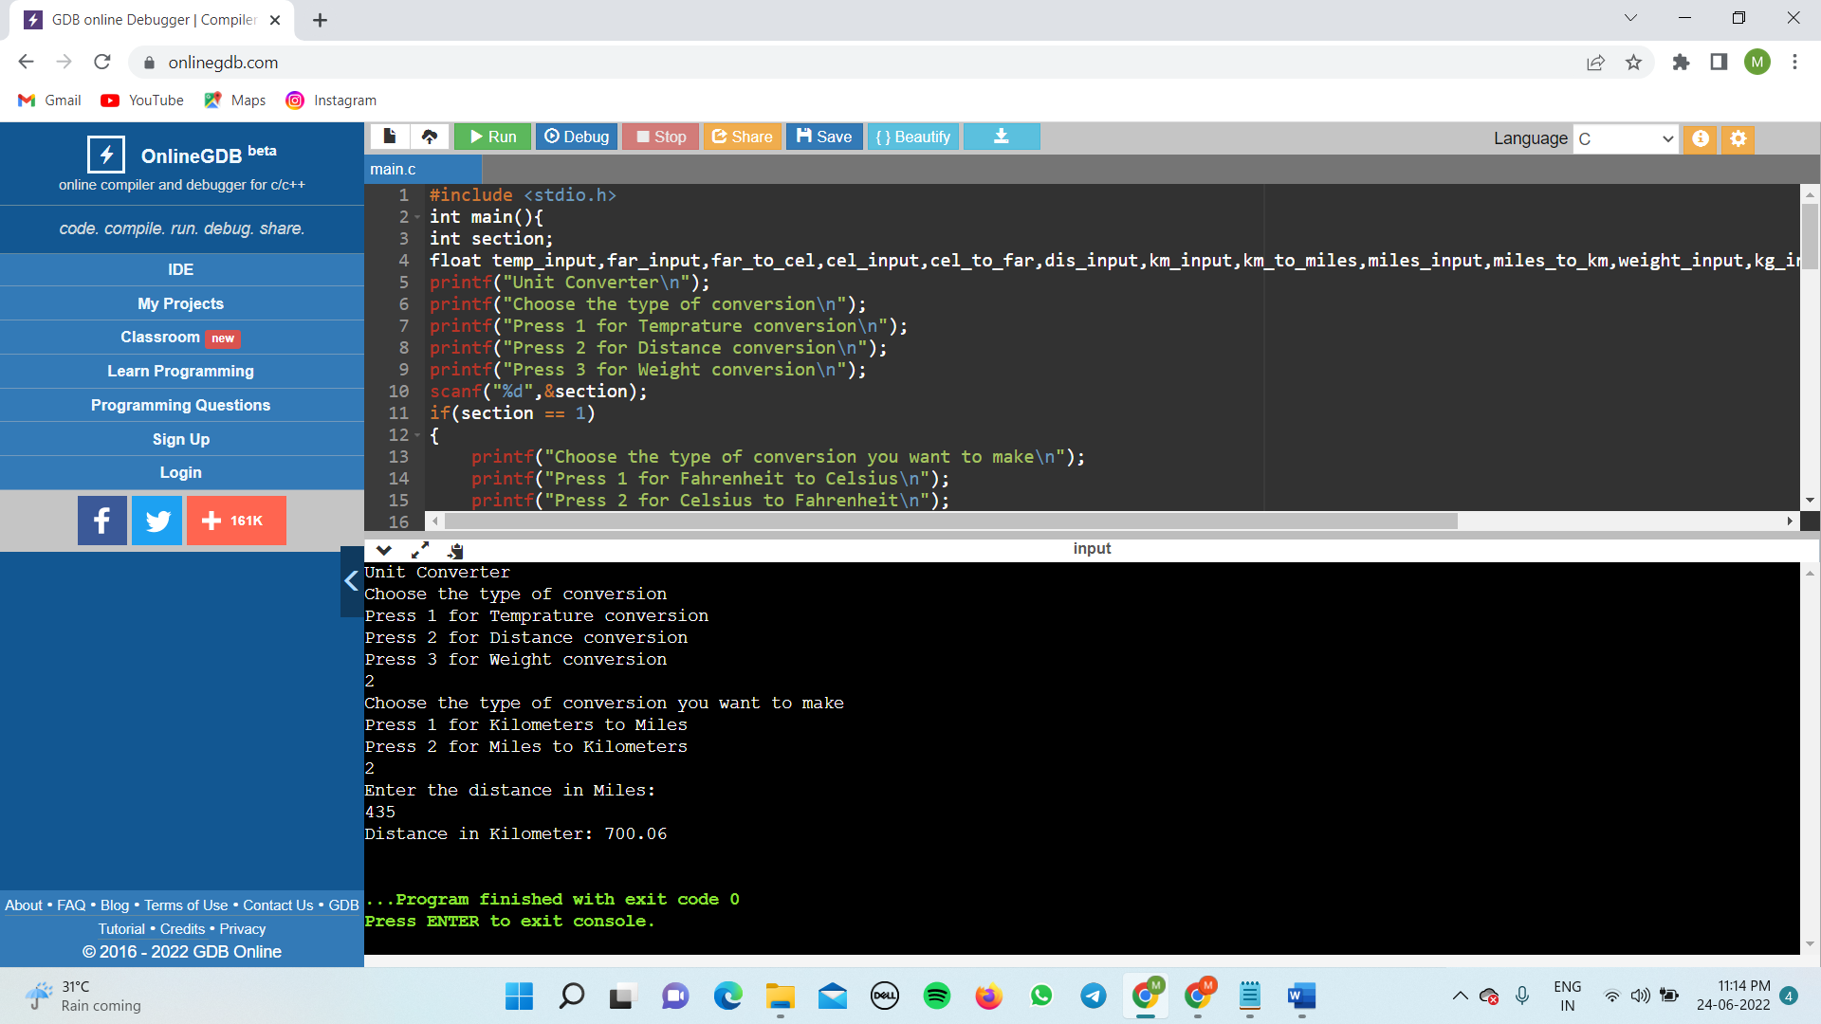

CASE 5 :

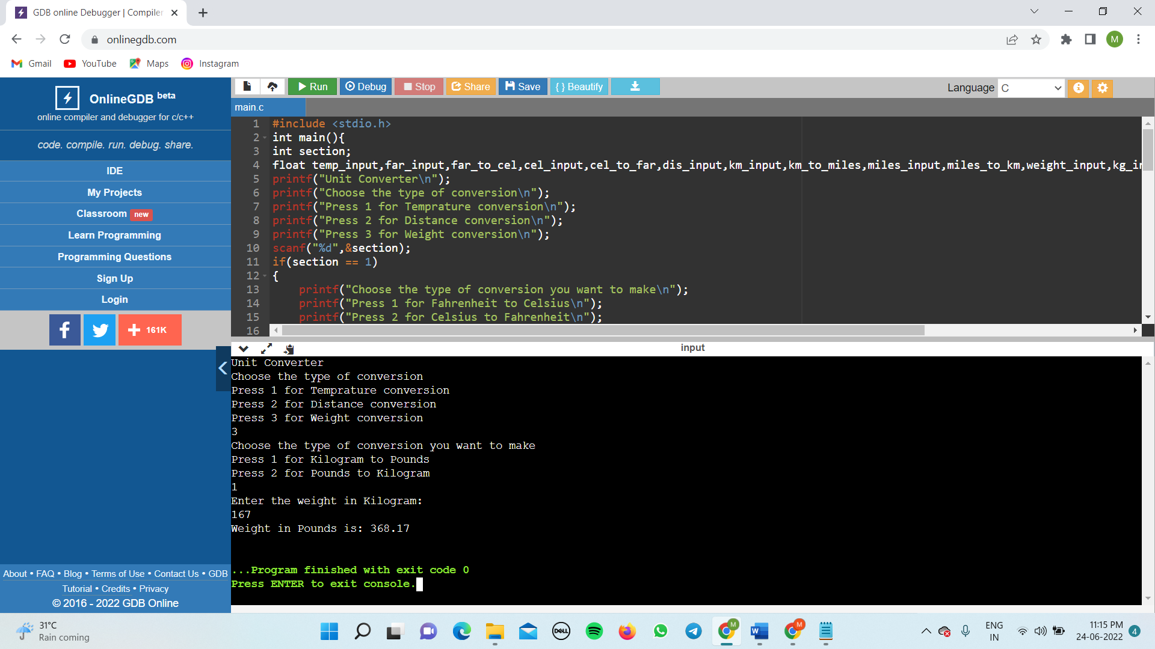

CASE 6 :

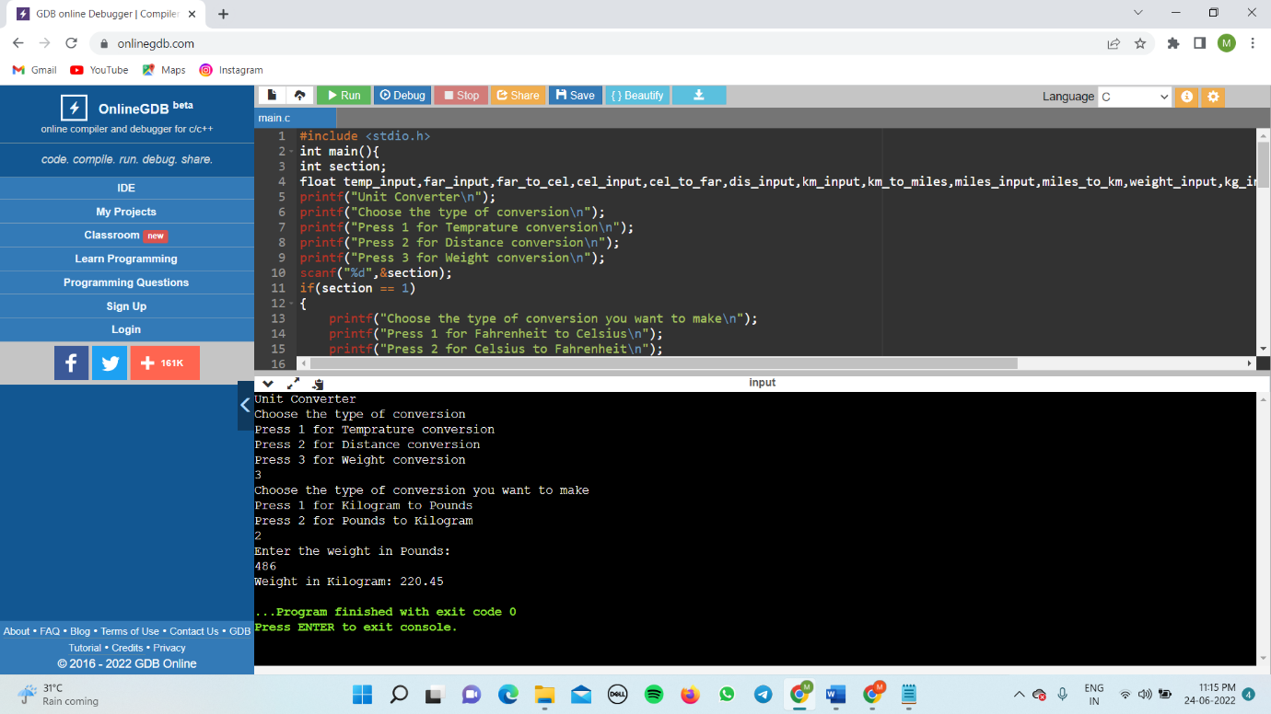  
 THANK YOU